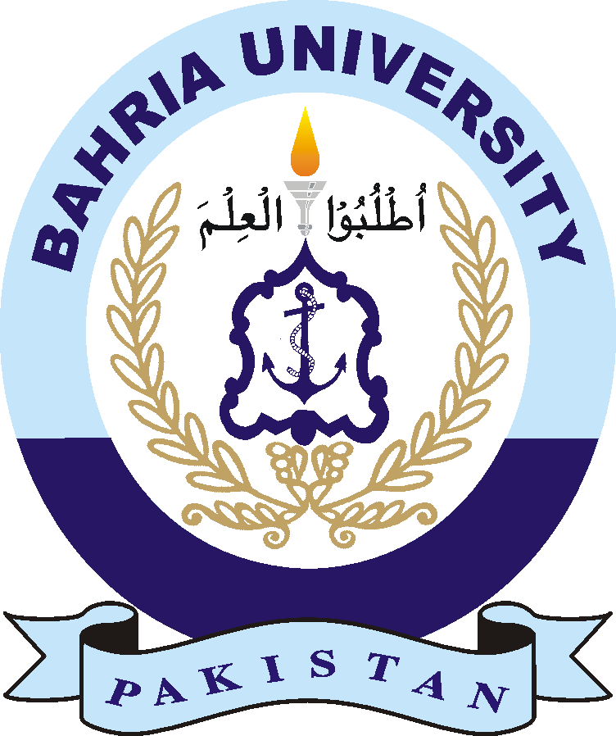
BAHRIA UNIVERSITY ISLAMABAD CAMPUS
APPLICATION FOR ISSUANCE OF DEGREE COMPLETION/ HOPE CERTIFICATE

STUDENT INFORMATION (FILLED IN BLOCK LETTER)
- Name: ______________________________ Father Name: _______________________________
Enrollment #: _________________ Reg # :______________ Degree Program: ____________________
Degree Status: completed/Current semester: ______________________ Contact No: _______________
Email: _____________________________

2. It is requested that I may please be issued following certificate

- Hope Certificate
(hope will not be issued if taking Extra Semester)

- Completion Certificate
(Attach Copy of Final Transcript)

Date: - ___________ Students Signature: ______________________

Note: (Processing time for issuance of above certificates is 05 working days after submission.)

