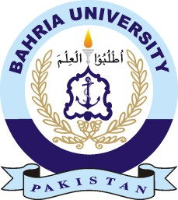
Bahria University Health Sciences Campus Naval Anchorage Islamabad

INVITATION OF BIDS FOR RUNNING OF CAFETERIA

Dated: 02 June- 2025
- Bids are invited from reputed firms/ Parties having experience for running of cafeteria at Bahria University College of Medicine Naval Anchorage Islamabad. Interested individual/ Firm/ Parties may submit their offers by 17 June 2025.
- Detail of facilities available/ required can be obtained from the office of DD(A&C) BUCM Naval Anchorage Islamabad.
- Bids will be opened at 1130 on 17 June 2025.
- Bahria University Reserve the right to reject any bid at any stage as per PPRA rule 33.

Director Campus

Bahria University Health Sciences Campus Naval Anchorage Islamabad

Ph No- 051-8855232

